Agent Migration Preparation

Prior to migration to the new management console, all endpoints will need to be online in the management console and free of any unresolved threats.
On the console, navigate to Sentinels > incidents. Filter this page for Incident Status unresolved for the past year to ensure all incidents are found:
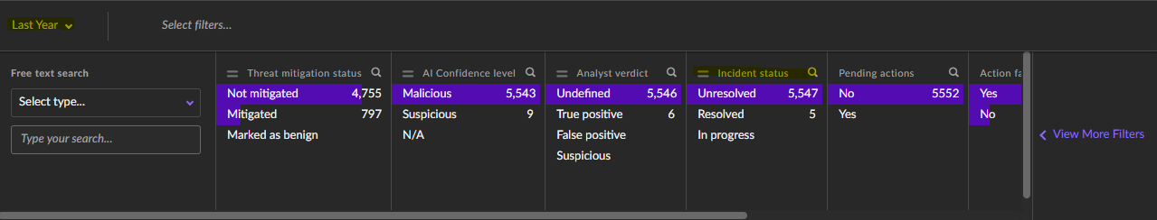

Incidents can be resolved in bulk from the incidents page. Select the incidents using the check box at the top:
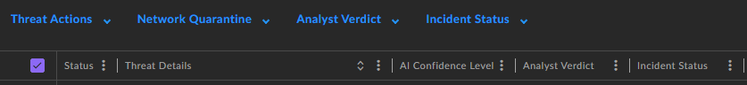

then first select Analyst Verdict,
Then change Incident status to resolved
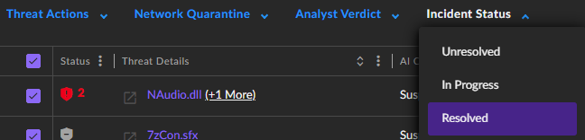

Once all incidents have been resolved we can then begin to migrate each endpoint to the new console.

