Read Me First
  - Sell smarter with Dynamics 365 Sales campaign materials
Welcome to the Sell smarter with Dynamics 365 Sales campaign. The materials provided are intended to supplement your own marketing and sales efforts. While they are ready to be shared with customers immediately, we highly recommend that you customize the materials to include your own unique value proposition, solution story, branding, logos, and calls to action.

Pitch Deck
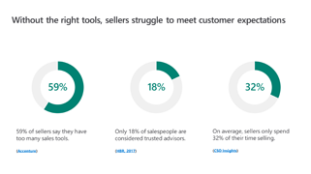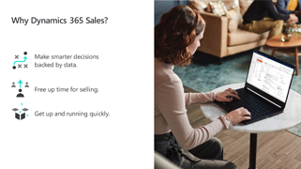
The pitch deck is intended to be used at customer-facing meetings, on calls, or for a webinar. It tells the story of the Sell smarter campaign and details the benefits of the Dynamics 365 Sales solution.
Be sure to add your own value proposition, detail your solutions and/or services, share your own customer case studies or testimonials, and include your contact information and branding throughout, so your customer and prospect recognize your role in implementing a Dynamics 365 Sales solution.

Solution Overview
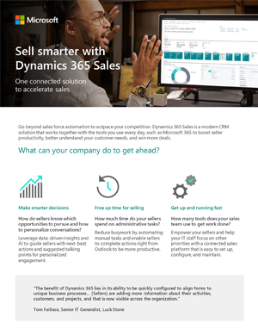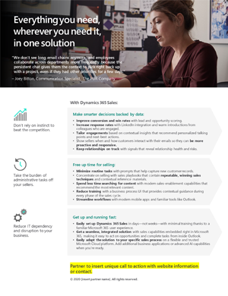
The solution overview can be printed as a leave-behind after a customer meeting, a handout at a customer event, or attached as a PDF to an email.
It is designed for you to add your logo, call to action, and contact information. Feel free to modify any of the copy to include your unique solution or service messaging to enhance the Sell smarter with Dynamics 365 Sales story.

Infographic
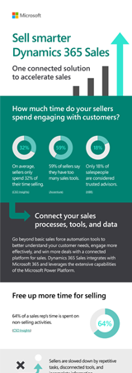
The infographic is a digital asset that can be shared in social media posts, posted to your website, or linked to from a blog post. Be sure to customize the copy when you post this asset to include your unique value proposition and call to action. You can add your logo and contact information in the white space at the bottom.

However, the infographic was created in Adobe Illustrator, so you will not be able to edit it unless you have access to Adobe software. Most designers have access to Adobe tools and can edit this file, but you will not be able to open the file unless you have the software installed. Do not let that keep you from posting this asset and customizing the associated copy on your platform of choice.

Emails
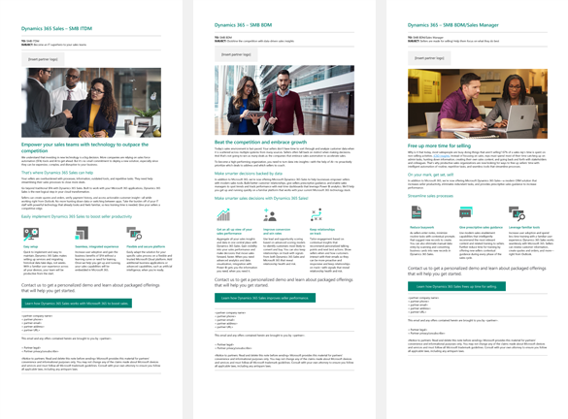
We have provided three nurture emails addressed to either the Business Decision Maker (BDM) or an IT Decision Maker (ITDM) audience. The emails are formatted in Word to make them easy to copy and paste into your email platform of choice. We recommend using a digital automation platform that will enable you to track metrics and plan a nurture email flow.

Social Copy
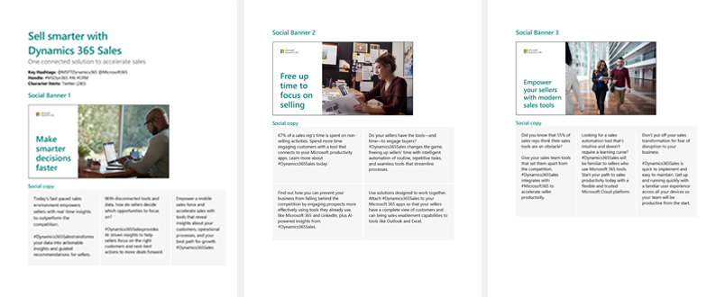
There are three social media banners included in the Sell smarter with Dynamics 365 Sales bill of materials. Each has been optimized for both LinkedIn and Twitter. Please be sure to post the right graphic to each platform to ensure it displays correctly.
(Note: The image files are included in a .zip file, which is embedded in the first page of social copy document. Please do not copy the banners directly from the Word document.)
Each banner has recommended social media copy included. Please customize the copy to include your unique value proposition, service offering, call to action, or link to your Dynamics 365 Sales landing page.

Sales Script
Leverage these talking points while on sales calls to address customer pains and understand where they are in their CRM buying journey. This script will help your salespeople target the right customers who are likely to buy a Dynamics 365 Sales solution and will offer guidance around how to nurture those prospects with open-ended questions and solution proof points.
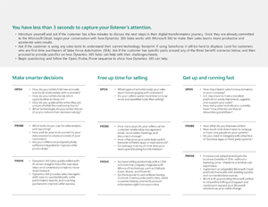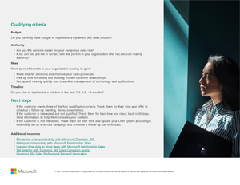

Additional Resources
While the resources above are intended to supplement your own marketing and sales efforts and help your organization capture new customers, we would also like to highlight additional resources designed to support your organization no matter where you are with your Dynamics 365 practice.
- Check out the US SMB Dynamics 365 Sales Landing Page for technical, sales, and marketing resources related to Dynamics 365 Sales.
- Read the e-book to understand how unification of business and productivity applications helps customers modernize their sales productivity and watch the video to see it in action.
- Explore the Dynamics 365 Sales Professional Help Resources for a deeper technical understanding of working with a Dynamics 365 Sales Professional.

